Project 2 Report

Maria Corella

[corella_m@knights.ucf.edu](mailto:corella_m@knights.ucf.edu)

EEL3801: Computer Organization

Due Date: Wednesday, July 29th, 2020

1. **Project Description**

This project is comprised of two parts. The objective of the first part of the project is to be able to read a string in MIPS and properly iterate through it to count the number of times specific characters occur within the string which is out input. We iterate through the string by advancing the address one location at a time and loading the value at that address into a register. We check to see if that character, whether in uppercase or lowercase, matches the list of characters we are tracking. Once we store the counter for each tracked character and have iterated through the entire string, we then print it to the console and print out a histogram of each letter. The second part of the project is analyzing various elements of the previously created code. We use the code and just change the input string to 5 sentences with different lengths. We analyze the dynamic instruction count using a built-in function from MARS and then proceed to calculate the total instruction count by using predefined CPI for each type of instructions. We also use the MARS instruction statistics tool and a predefined list of energy consumption per instruction type to calculate the energy consumption of running the program. Another section of the second part of this project is to try to improve the instruction count and energy consumption of the project by modifying the code without changing the overall functionality of it and without altering the input string. We then run the same instruction count and energy calculations we did to the unenhanced program and compare the improvement between these two programs.

1. **Program Design**

**2.1 Assembly Code Explanation**

We get a test input string. We load this, a new line, and the output format into the .data field of the MIPS program. Next, we assign register to the different counters we will be using. We are tracking the characters C, H, A, R, G, E, O, N in lower and uppercase. Within the .text part of the code we first initialize all the counters we’ll be using. We need 8 counters for the letters initialized to 0, one register will hold the character we are currently analyzing and another counter that will hold the loop counter used to print out the histogram. We then load the address of the string to an address register which we then load into the temporary register that hold the character we will currently be analyzing. We then start a loop where we will be comparing this character to the ones we are tracking in uppercase and lowercase resulting in 18 total beq branches. At the beginning of the loop we place a beqz instruction, so we know if we have reached the end of the string. Once we do reach the end of the string, this instruction will branch to the exit command which starts the output part of the program. f If the character we are analyzing matches with one of the beq branches then it shall advance to the branch for that character. There are 8 total branches, one for each of the characters we are tracking. Each branch serves the same purpose, it increments the counter of the corresponding letter by 1, advances the address by 1 to read the next character in the string and then jumps back to the loop that compares the current character to the characters we are tracking. Once we reach the end of the string and branch to the exit part of the code, we start printing out the character count. We do this by loading the print command for the corresponding letter and print it, we then load the counter for that letter and print that value. We do this for all 8 letters. After we print out this count, we need to print out the histogram. We first print out the right format for the letter we are working with for example “C:”, we set the loop counter to zero and then we start a loop for this character. We will have the same loop for each character that starts after we print out the character format declared in the .data section of the code. Each loop will jump to the next loop once the loop counter has reached the character counter for that letter. If this hasn’t happened then we need to print out the pound sign, increment the pound sign counter by 1 and then jump back to the beginning of this loop. After having don’t the respective prints and loops for each letter then we reach the end of the program where we load the exit command and execute the syscall.

**2.2 Part B Optimization**

We need to enhance the code to provide an enhancement of at least 5% for energy consumption. To enhance my code, I improved the amount of beq checks that the program had to run through. I looked at the output for character count and realized some letter occur more frequently than others. The letters occur in descending order O, N, E, A, R, C, H, G. I also noticed that lowercase letters occur more often than uppercase letters within a single sentence. Using this knowledge, I modified the order of the beq instructions to check for the letters in the order O, N, E, A, R, C, H, G in lowercase and then the same order of letters in uppercase. This will result in less beq instructions having to be executed which will decrease the instruction count thus decreasing the energy consumption. This means the loop runs the same amount of times, but on average it runs less lines of code before branching out then it did before. I didn’t modify any line of code; I just altered the order in which the letters are checked within the loop.

**2.3 Flowchart**

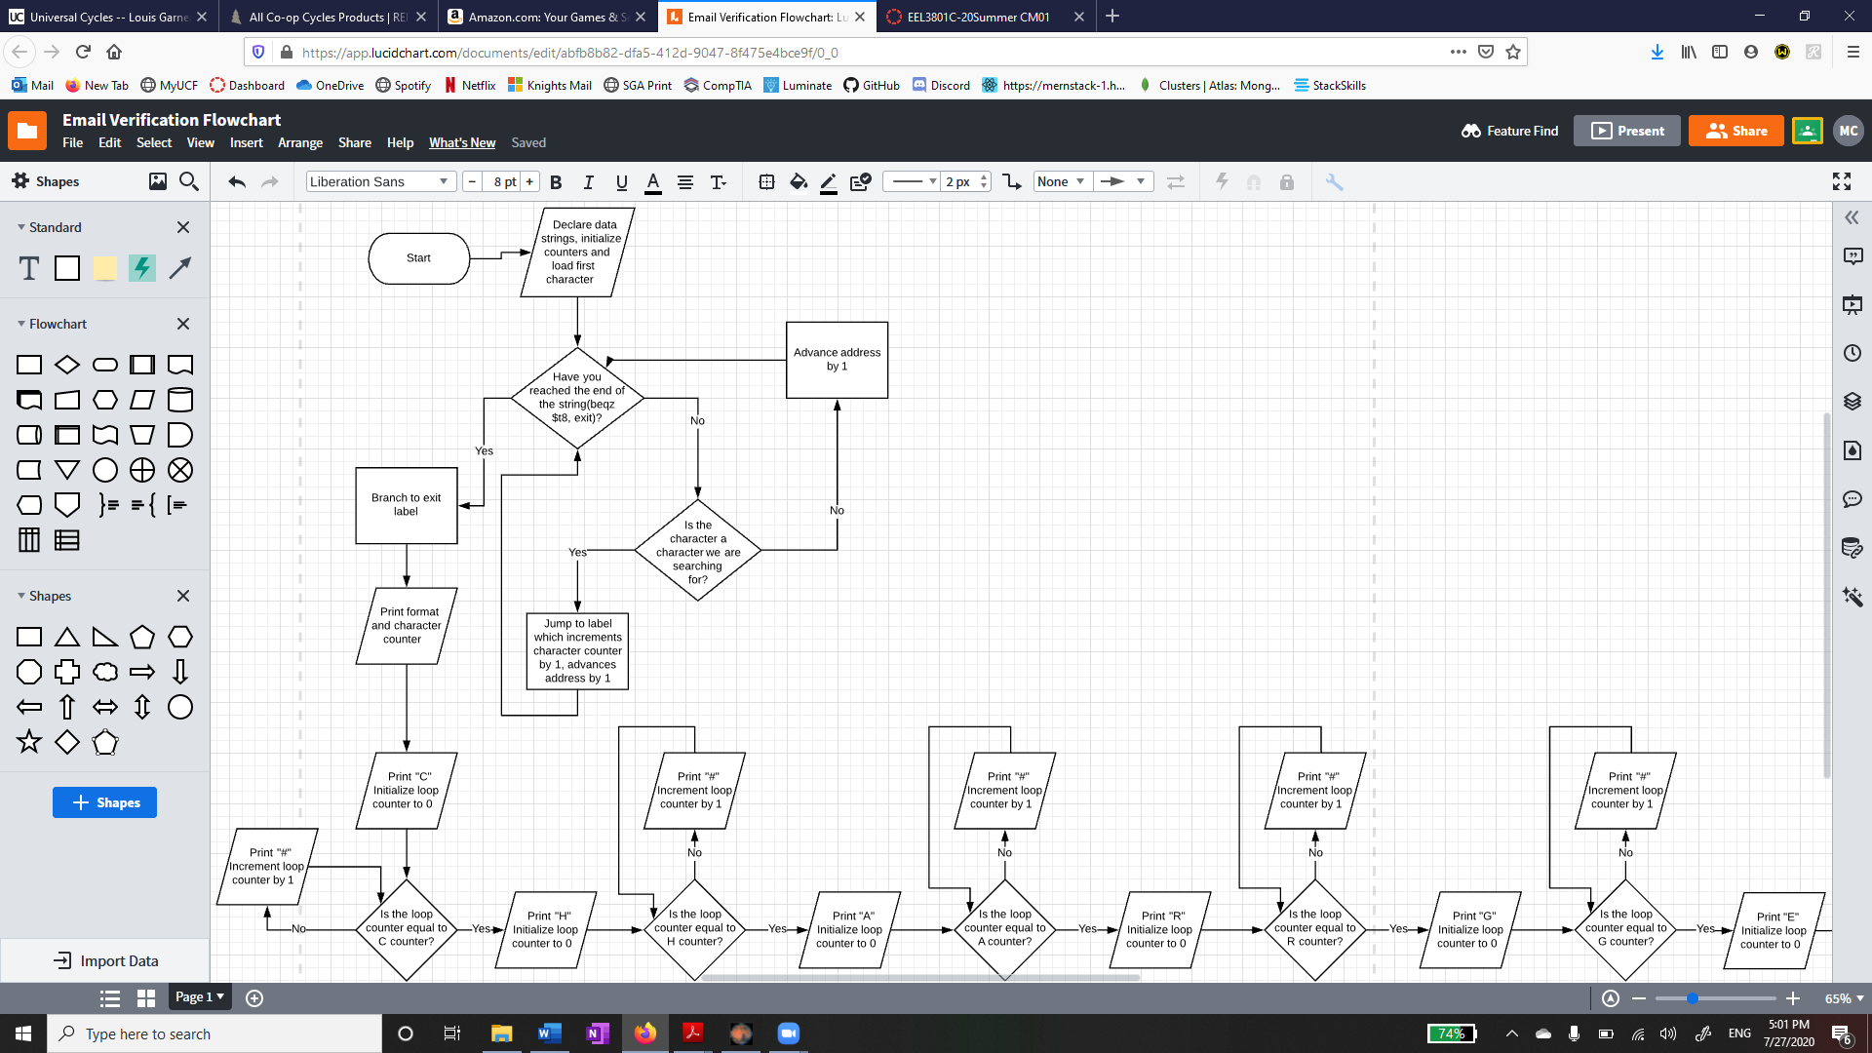



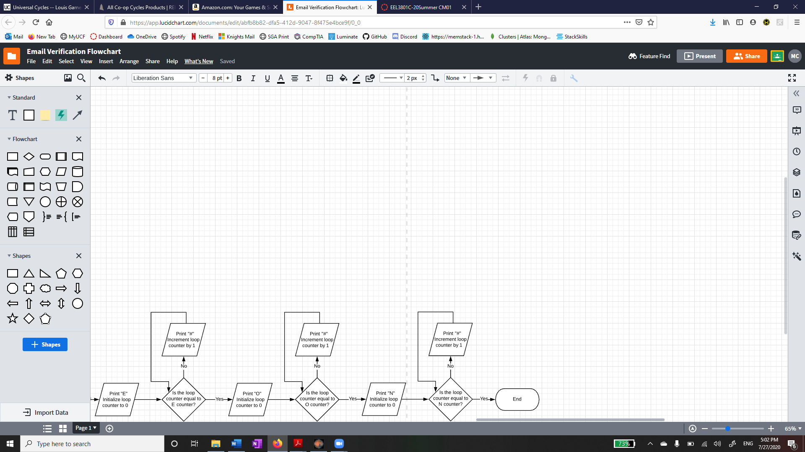

1. **Symbol Table**

**3.1 Register Table**

|  |  |
| --- | --- |
| Register | Use |
| $t0 | Used to hold C counter |
| $t1 | Used to hold H counter |
| $t2 | Used to hold A counter |
| $t3 | Used to hold R counter |
| $t4 | Used to hold G counter |
| $t5 | Used to hold E counter |
| $t6 | Used to hold O counter |
| $t7 | Used to hold N counter |
| $t8 | Used to hold the current character we are working with |
| $t9 | Used to hold a loop counter |
| $a0 | Used to hold the address of the input string |
| $v0 | Used for syscall and return value |

**3.2 Label Table**

|  |  |
| --- | --- |
| Label | Use |
| str | Starting address of the string to be analyzed |
| ccount | Starting address of the string “C:” |
| hcount | Starting address of the string “\nH:” |
| acount | Starting address of the string “\nA:” |
| rcount | Starting address of the string “\nR:” |
| gcount | Starting address of the string “\nG:” |
| ecount | Starting address of the string “\nE:” |
| ocount | Starting address of the string “\nO:” |
| ncount | Starting address of the string “\nN:” |
| pound | Starting address of string “#” |
| newline | Starting address of string “\n” |
| loop | Address of loop that will count the respective letters |
| labelc | Address of loop for c counter |
| labelh | Address of loop for h counter |
| labela | Address of loop for a counter |
| labelr | Address of loop for r counter |
| labelg | Address of loop for g counter |
| labele | Address of loop for e counter |
| labelo | Address of loop for o counter |
| labeln | Address of loop for n counter |
| exit | Address of the loop to print and exit the program |
| cpound | Starting address of loop to print # for C |
| hpound | Starting address of loop to print # for H |
| apound | Starting address of loop to print # for A |
| rpound | Starting address of loop to print # for R |
| gpound | Starting address of loop to print # for G |
| epound | Starting address of loop to print # for E |
| opound | Starting address of loop to print # for O |
| npound | Starting address of loop to print # for N |
| cpoundexit | Starting address of loop to restart counter and print format string |
| hpoundexit | Starting address of loop to restart counter and print format string |
| apoundexit | Starting address of loop to restart counter and print format string |
| rpoundexit | Starting address of loop to restart counter and print format string |
| gpoundexit | Starting address of loop to restart counter and print format string |
| epoundexit | Starting address of loop to restart counter and print format string |
| opoundexit | Starting address of loop to restart counter and print format string |
| npoundexit | Starting address of loop to restart counter and print format string |

1. **Project 2 Part B**

For Part B of the project we had to carry out several calculations using the code produced from the first part. The sentences I used will be stated below along with the character count and screenshots of the instruction counter and instruction statistics of before and after the code was enhanced. To calculate the CPI of each instruction we assume that R-type instructions require 4 clocks, I-type instructions require 5 clocks, and J-type instructions require 3 clocks. I then used the formula:

((4 x # R ins) + (5 x # I ins.) + (3 x # J ins.)) / total instructions = Average CPI

To find the energy consumption I assumed ALU instructions require 4fj, jump instructions require 5fj, branch instructions require 8fj, memory instructions require 100fj, and other instructions require 3fj and I used the following formula:

((4 x # ALU) + (5 x # jump) + (8 x # branch) + (100 x # memory) + (3 x # other)) = total energy

To compare the unenhanced energy consumption to the enhanced one I used the formula:

Unenhanced energy / enhanced energy = improvement

To find the MIPS/mW for the optimized code I assumed the time per clock to be 400psec. To find the total clocks I used the formula:

((4 x # R ins) + (5 x # I ins.) + (3 x # J ins.)) = total clocks

Then I can find the total time by total clocks x 400psec = total time. We can multiply the instruction count by 10^-6 to find the million instructions. We now have the million instructions and time so we can find the MIPS value by doing million instructions / total time = MIPS. Next, we can find power by using energy / time = power. We can multiply this power value by 10^3 to find mW. Now that we have MIPS and mW, we can find MIPS/mw by doing MIPS / mW = MIPS/mW.

1. “UCF, go Knights! Charge on!”

Character count: 27

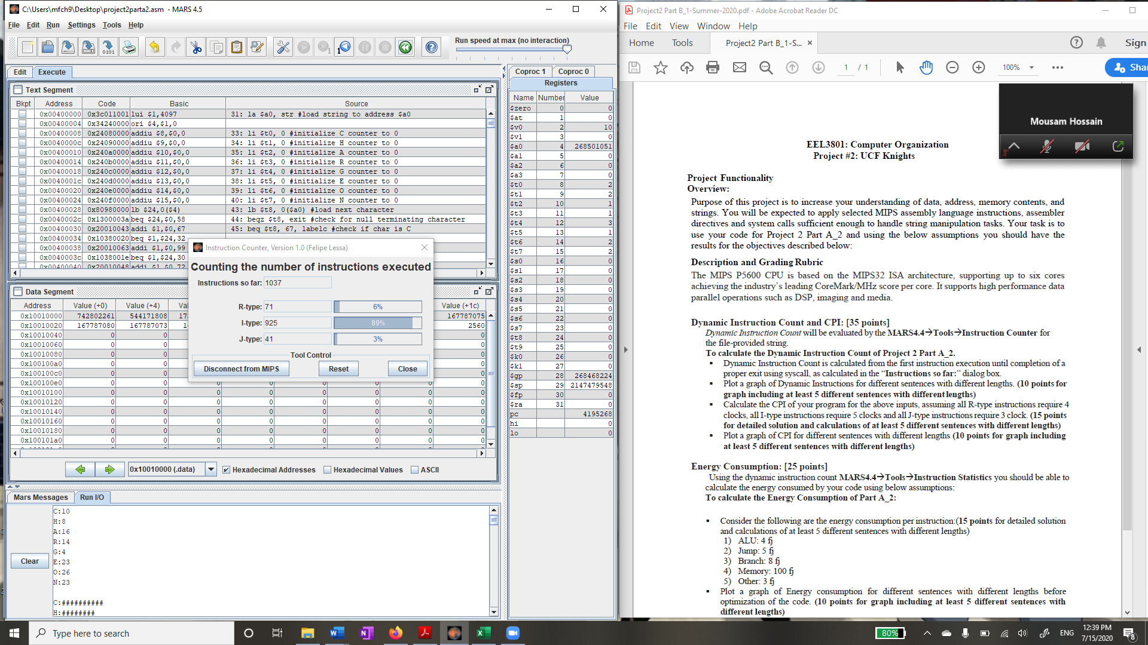

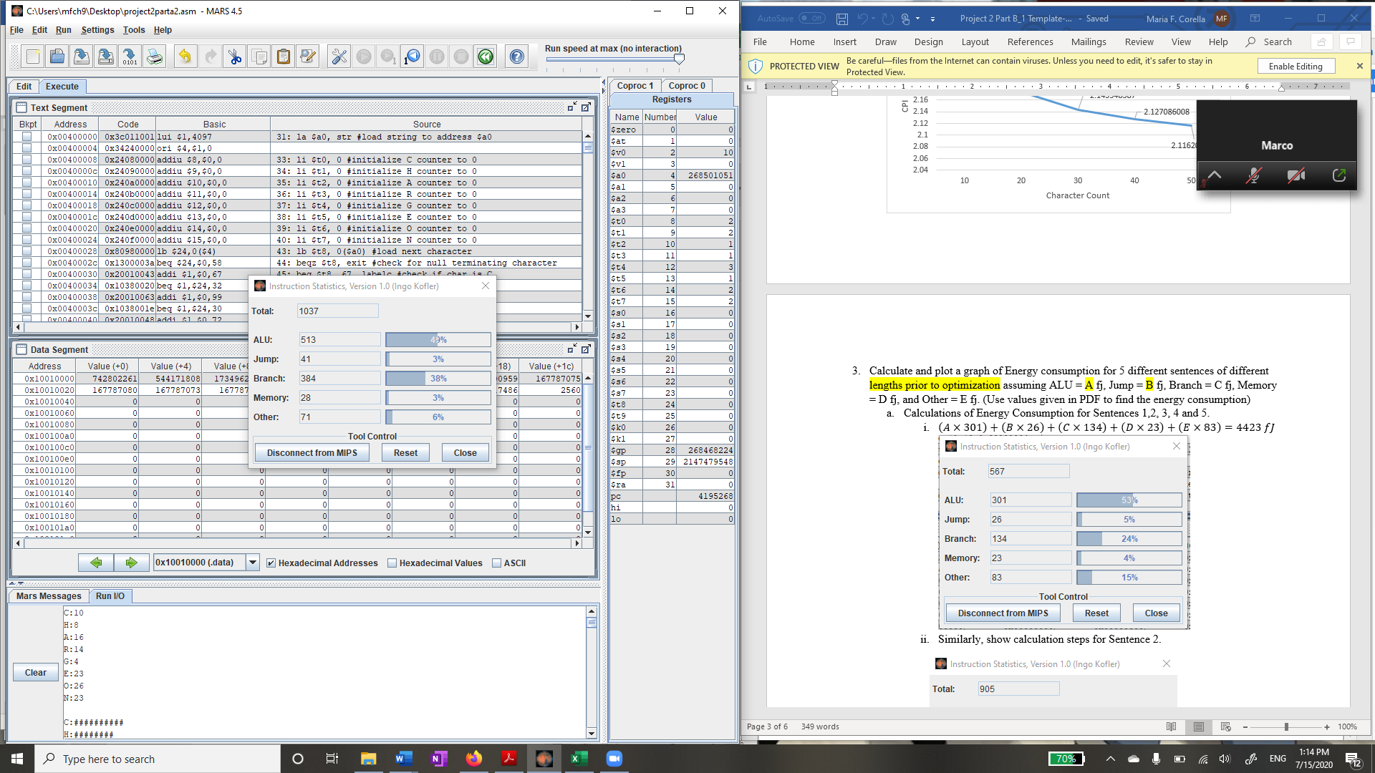

$\frac{\left(4×71\right)+\left(5×925\right)+\left(3×41\right)}{1037}$ = 4.85 = average CPI

$\left(513×4\right)+\left(41×5\right)+\left(384×8\right)+\left(28×100\right)+\left(71×3\right)$ = 8324fj = energy unenhanced

**After enhancing the code**

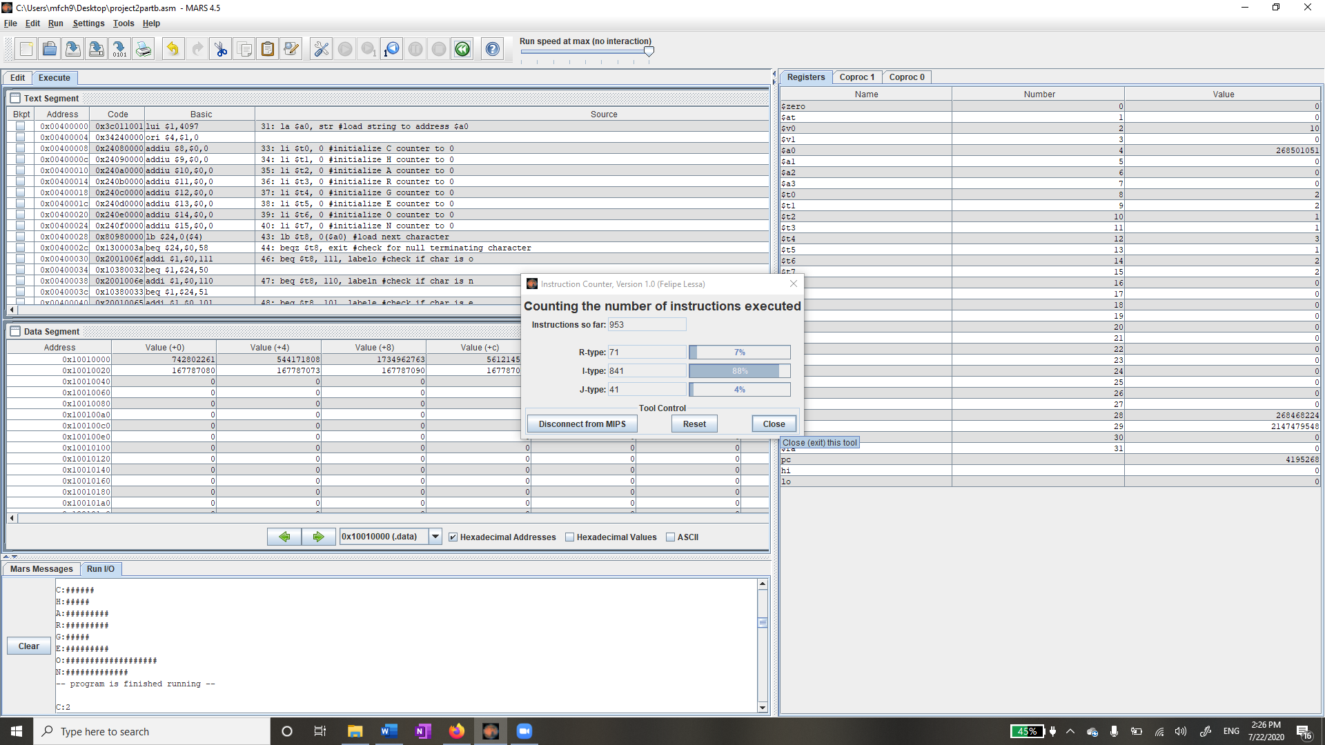

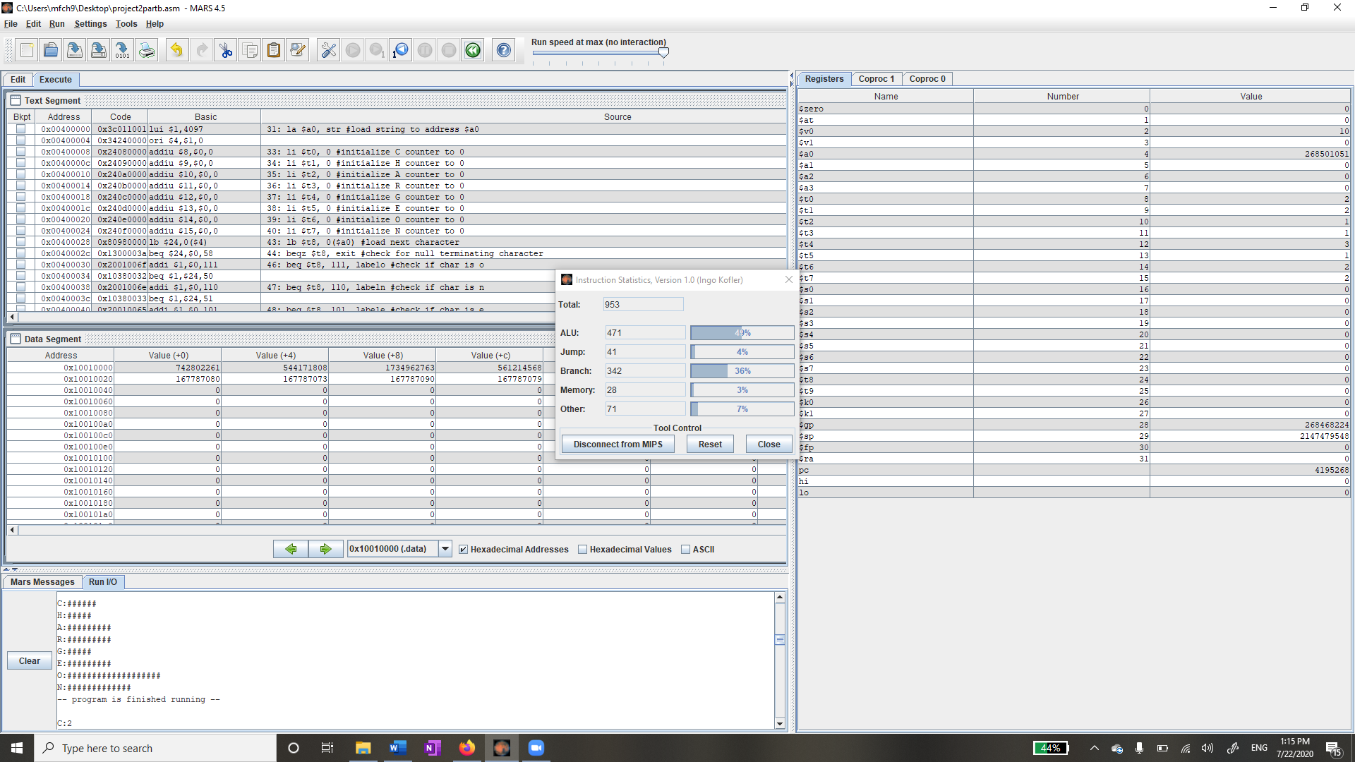

(71*4) + (841*5) + (41*3) = 4612 clocks = enhanced clocks

(471 * 4) + (41 * 5) + (342 * 8) + (28 * 100) + (71 * 3) = 7838fj = enhanced energy

Compared to unenhanced = 8324/7838 = 1.06 = 6% improvement

4612 clk * 400ps = 1,844,800 psec

953 x 10-6 instructions

If we divide these two, we get = 516.59 MIPS

Power = Energy/time = 7838fj/1,844,800psec = 4.25 x 10-6W = 4.25 x 10-3mW

MIPS/mW = 516.59/4.25 x 10-3mW = 121,550 MIPS/mW

1. “The MIPS P5600 CPU is based on the MIPS32 ISA architecture.”

Character count: 59

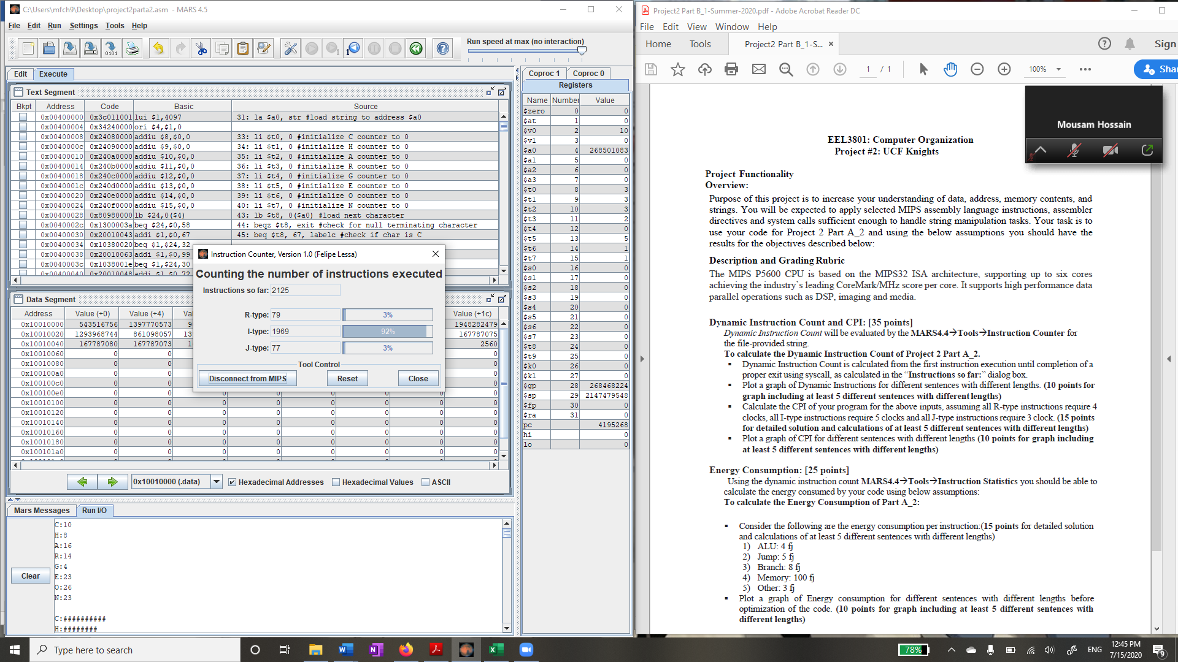

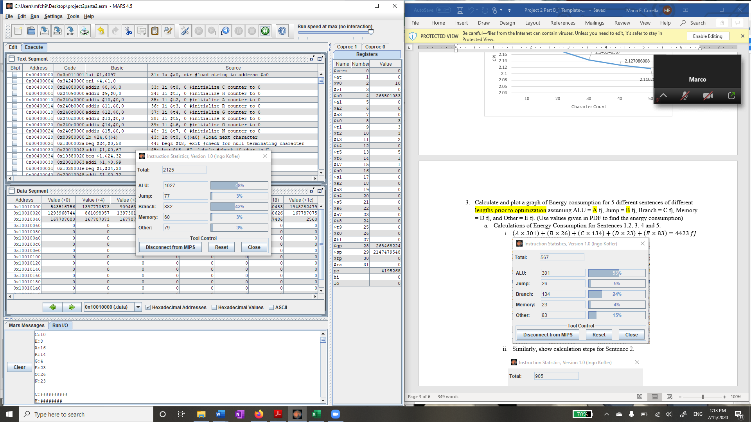

$\frac{\left(4×79\right)+\left(5×1969\right)+\left(3×77\right)}{2125}$ = 4.89 = CPI

$\left(1027×4\right)+\left(77×9\right)+\left(882×8\right)+\left(60×100\right)+\left(79×3\right)$ = 18194fj

**After enhancing the code**

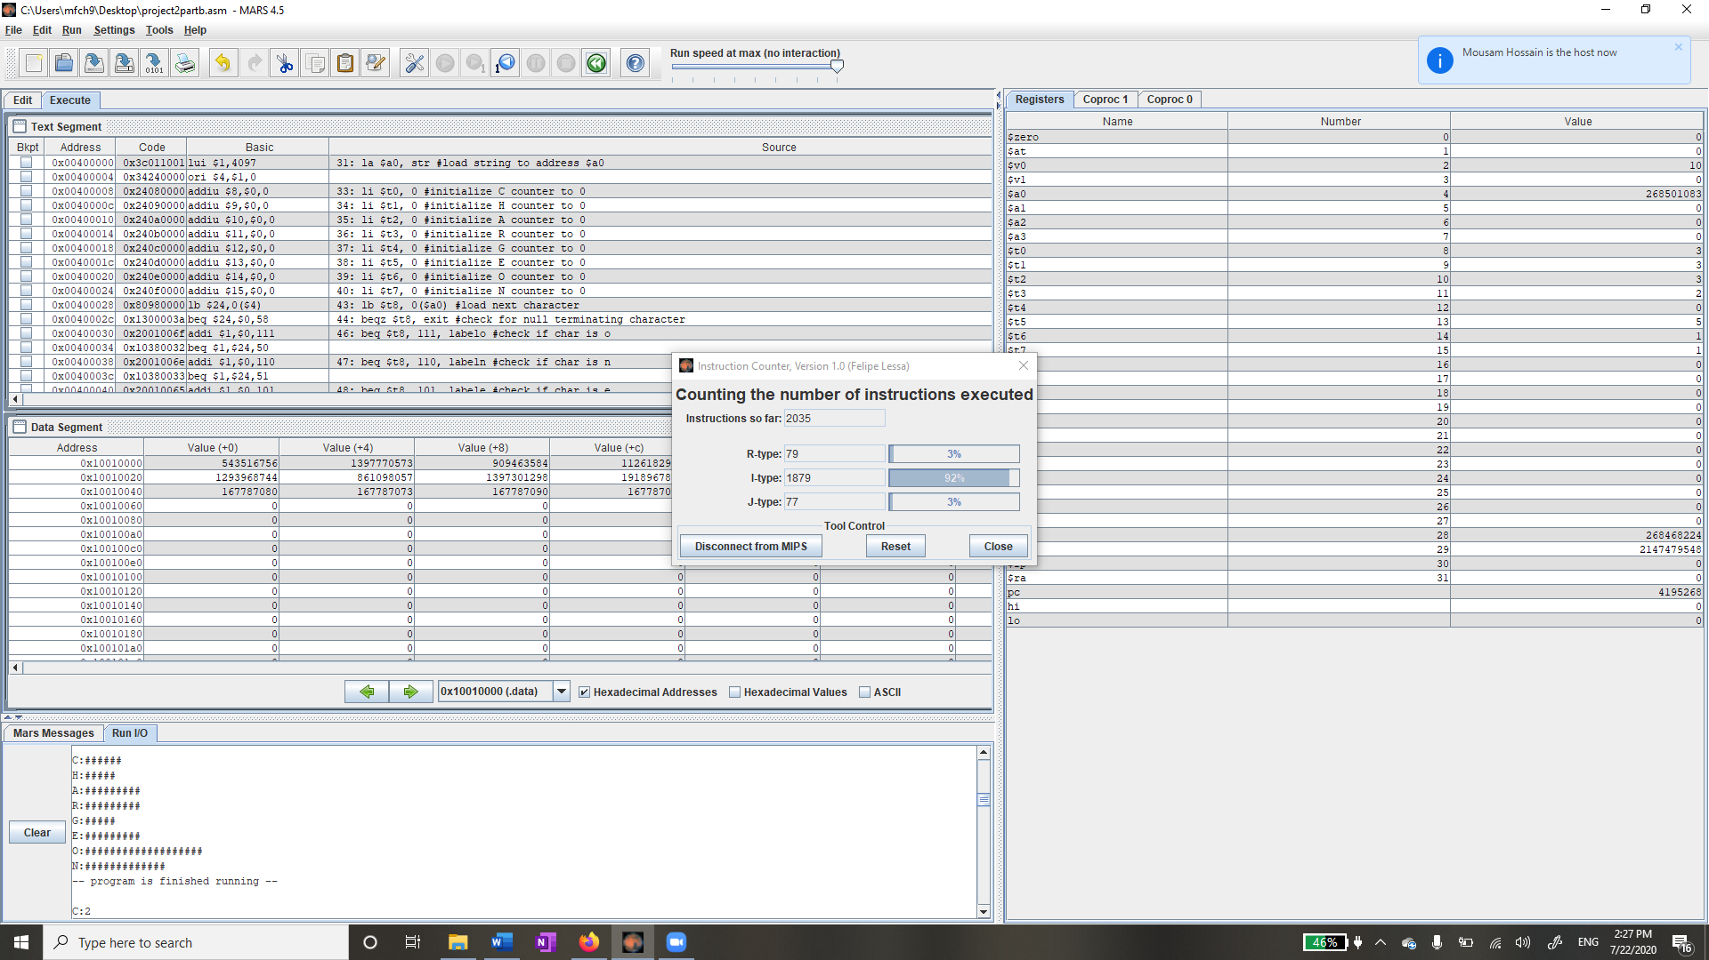

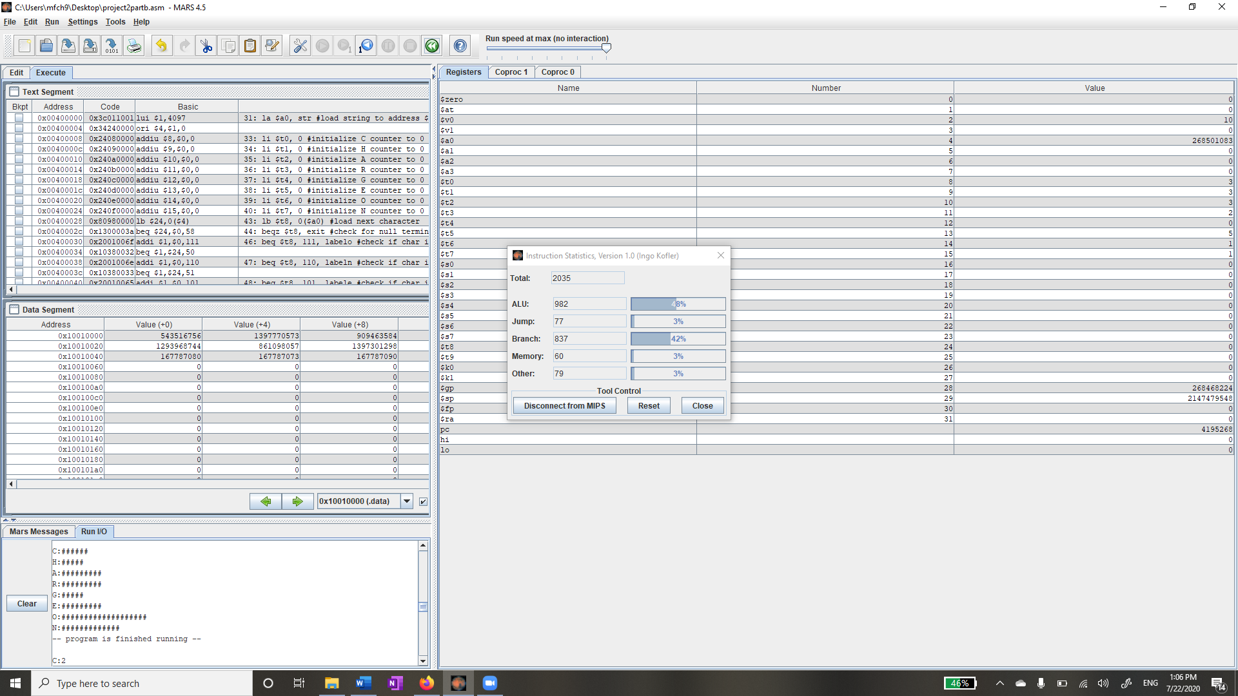

(79*4) + (1879*5) + (77*3) = 9942 clocks

(982 * 4) + (77 * 5) + (837 * 8) + (60 * 100) + (79 * 3) = 17246fj

Compared to unenhanced = 18194/17246 = 1.05 = 5% improvement

9943 clk * 400psec = 3,977,200psec

2035 x 10-6 instructions

If we divide, we get = 511.67 MIPS

Power = Energy/time = 17246fj/3,977,200psec = 4.33 x 10-6W = 4.33 x 10-3mW

MIPS/mW = 511.67/4.33 x 10-3 = 118,168 MIPS/mW

1. “The UCF Knights are the [athletic](https://en.wikipedia.org/wiki/Sport) teams that represent the [University of Central Florida](https://en.wikipedia.org/wiki/University_of_Central_Florida) in [Orlando, Florida](https://en.wikipedia.org/wiki/Orlando,_Florida).”

Character count: 108

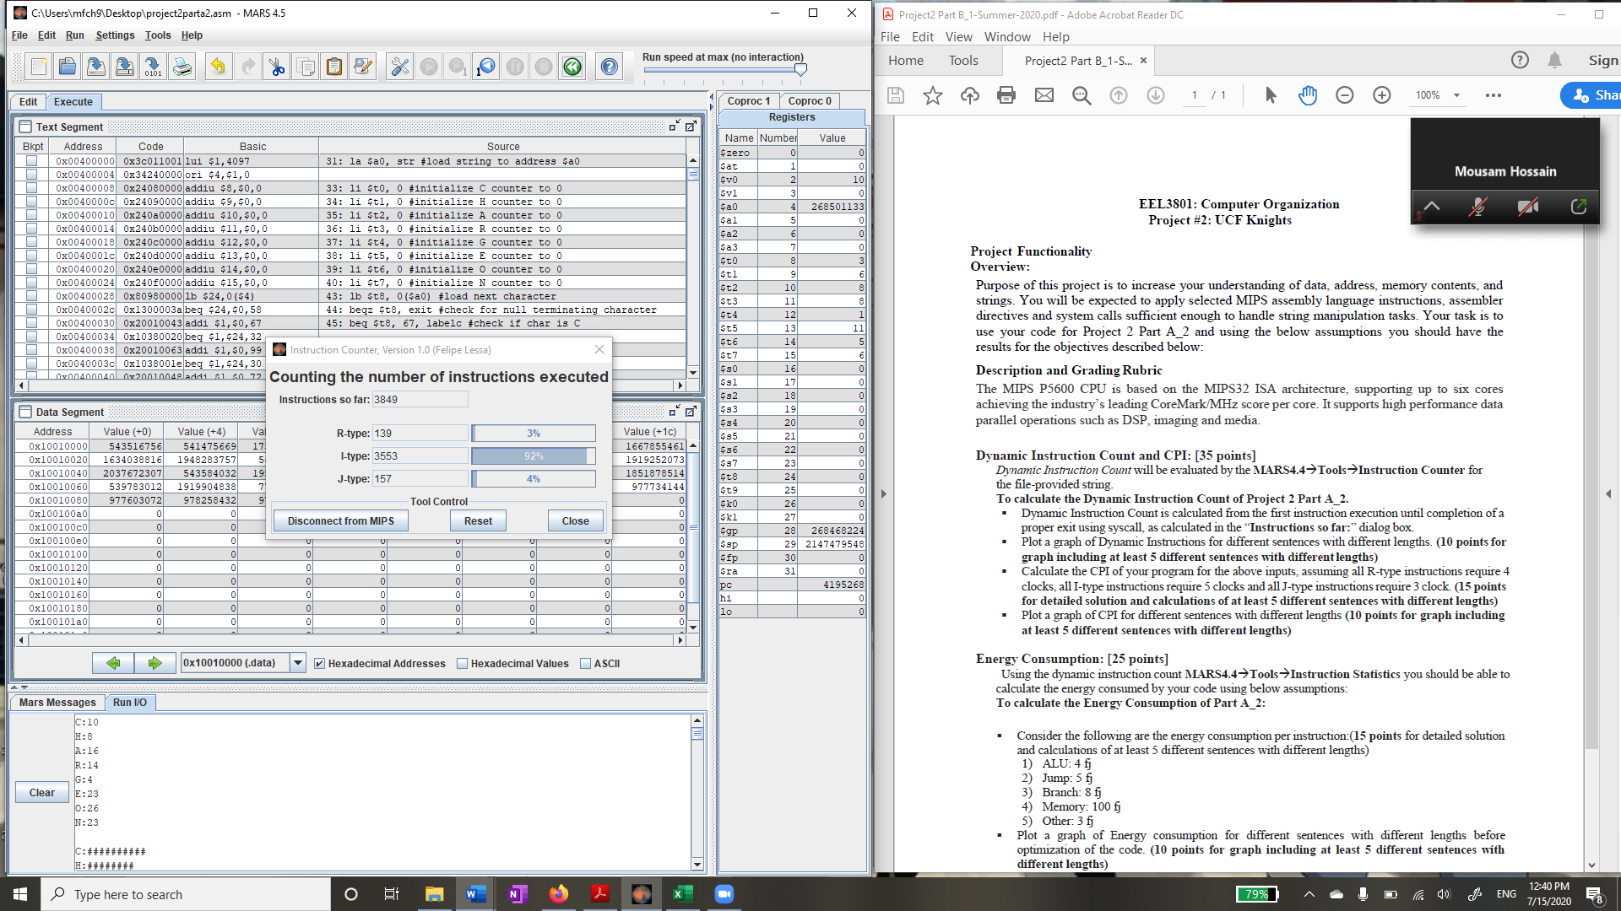

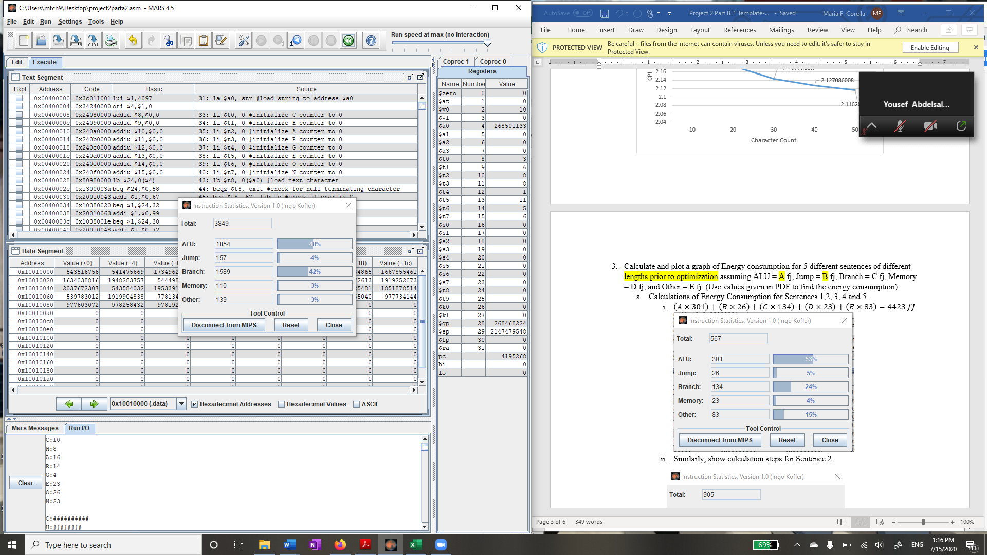

$\frac{\left(4×139\right)+\left(5×3553\right)+\left(3×157\right)}{3849}$ = 4.92 = CPI

$\left(1854×4\right)+\left(157×5\right)+\left(1589×8\right)+\left(110×100\right)+\left(139×3\right)$ = 32330fj

**After enhancing the code**

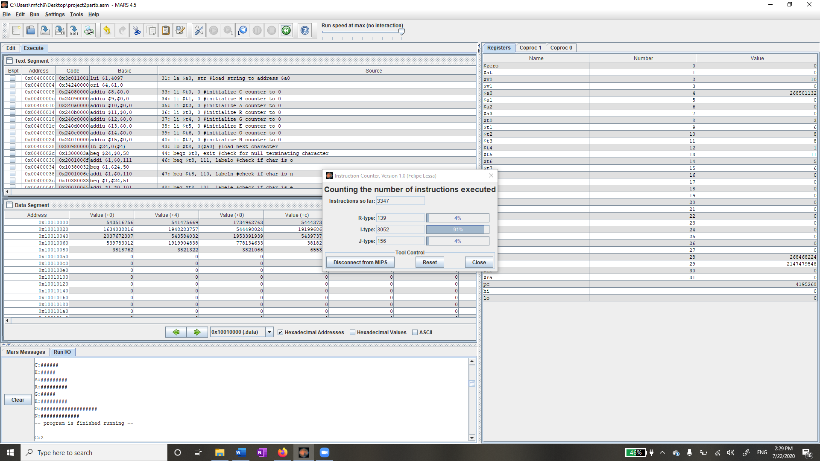

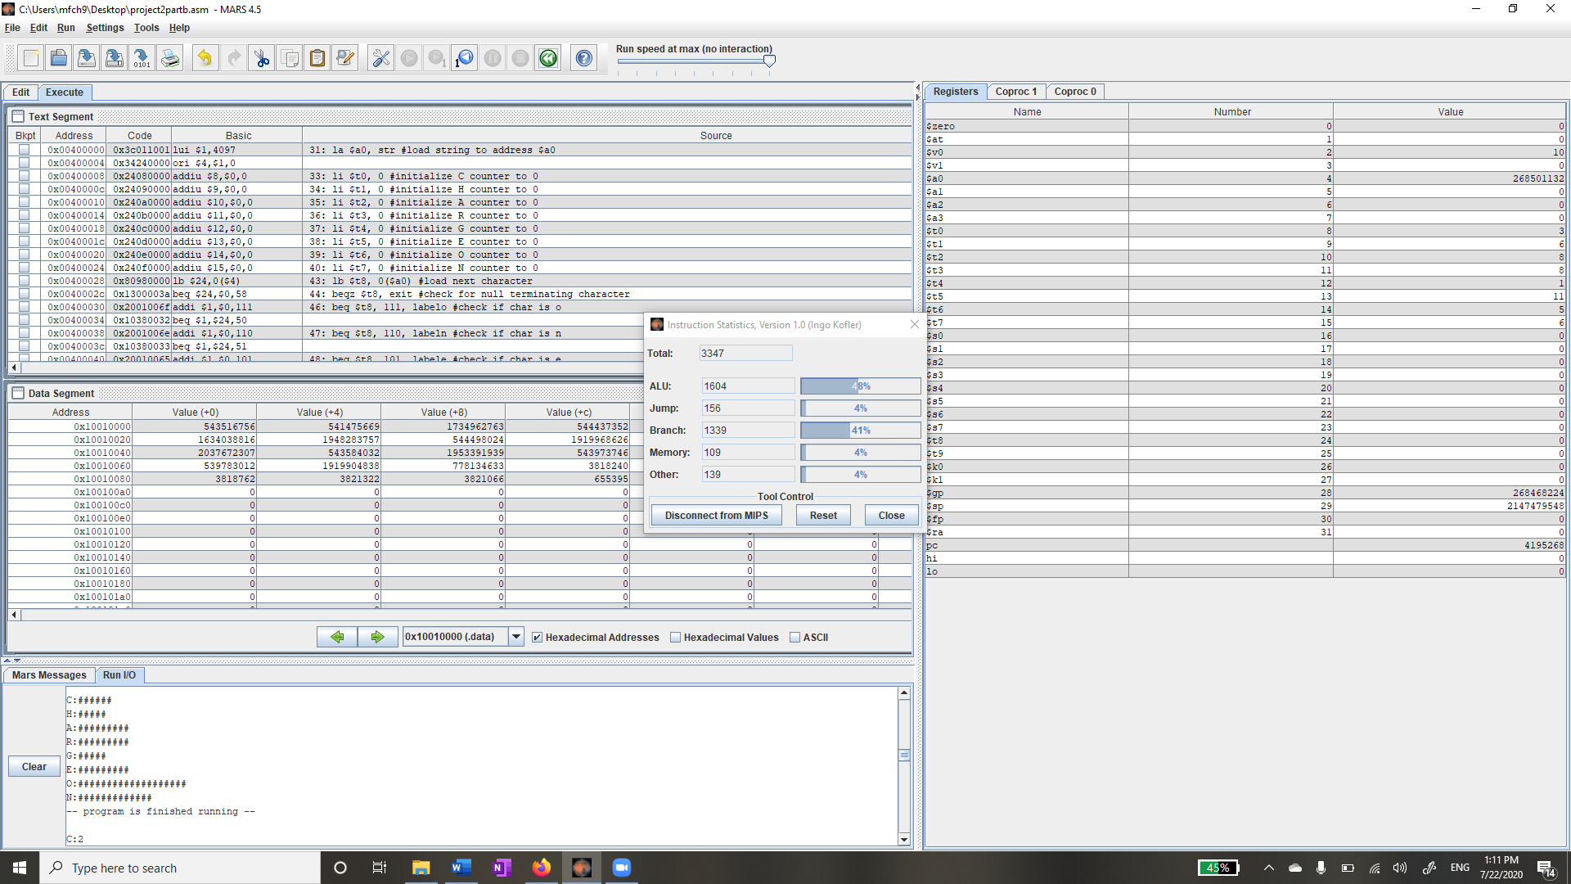

(139*4) + (3052*5) + (156*3) = 16284 clocks

(1604 * 4) + (156 * 5) + (1339 * 8) + (109 * 100) + (139 * 3) = 29225fj

Compared to unenhanced = 32330/29225 = 1.11 = 11% improvement

16284 clk * 400 = 6, 513, 600 psec

3347 * 10-6 instructions

If we divide these, we get = 513.85 MIPS

Power = Energy/time = 29225fj/6,513,600psec = 4.49 x 10-16 = 4.49 x 10-3mW

MIPS/mW = 513.85/4.49 x 10-3 = 114,433 MIPS/mW

1. “Bootstrap is downloadable in two forms, within which you'll find the following directories and files, logically grouping common resources and providing both compiled and minified variations.”

Character count: 190

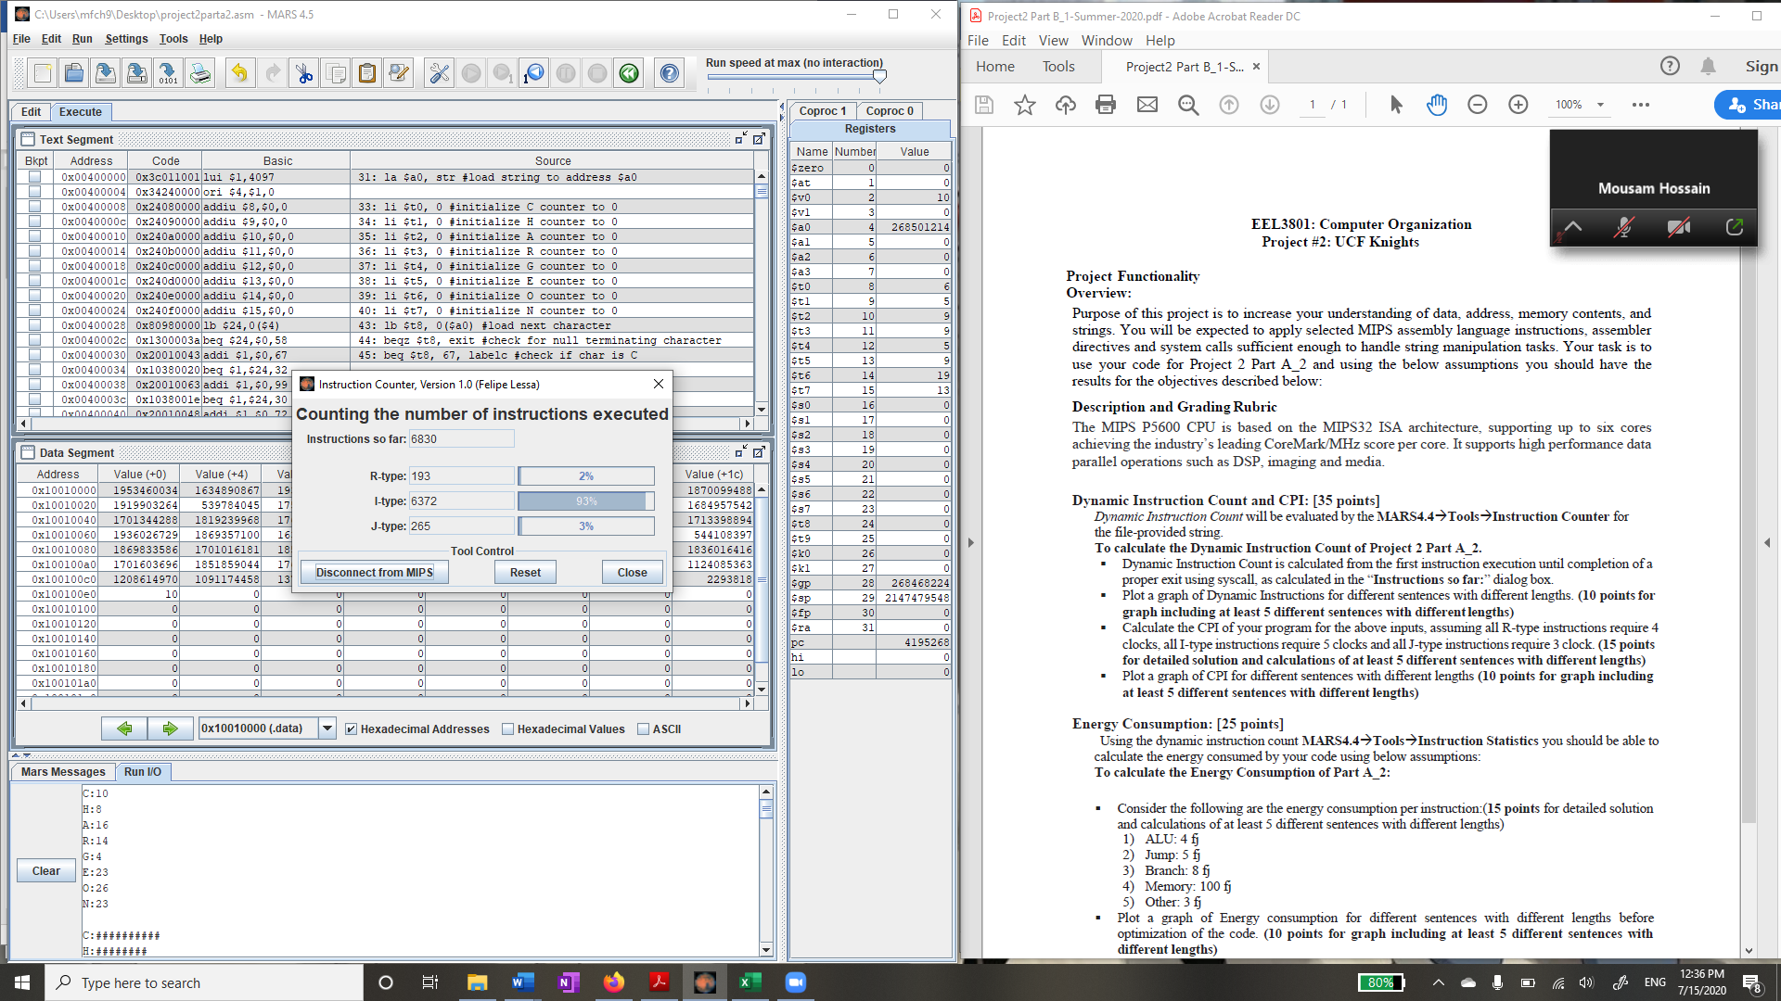

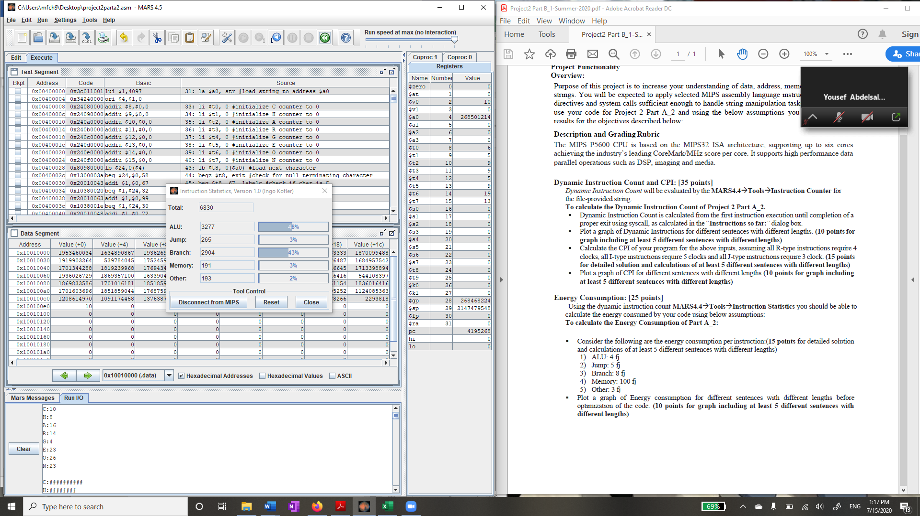

$\frac{\left(4×193\right)+\left(5×6372\right)+\left(3×265\right)}{6830}$ = 4.89 = CPI

$\left(3277×4\right)+\left(265×5\right)+\left(2904×8\right)+\left(191×100\right)+\left(193×3\right)$ = 57344fj

**After enhancing the code**

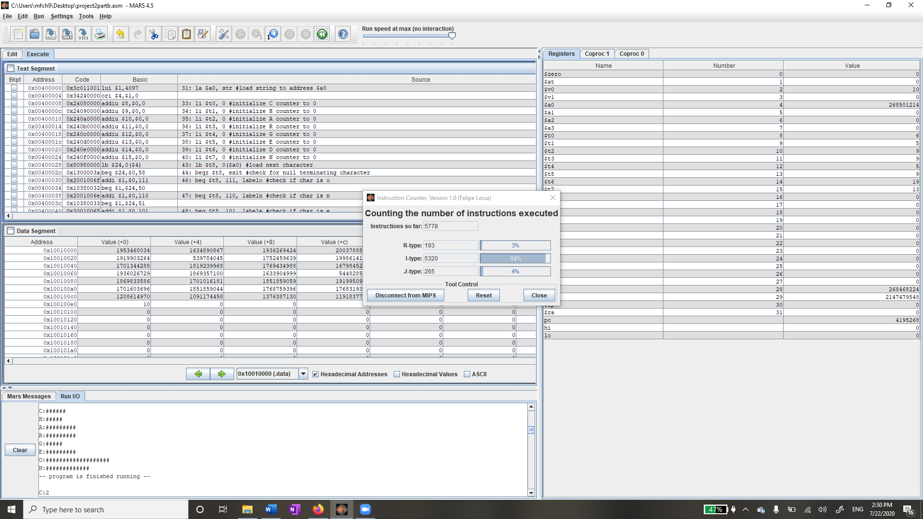

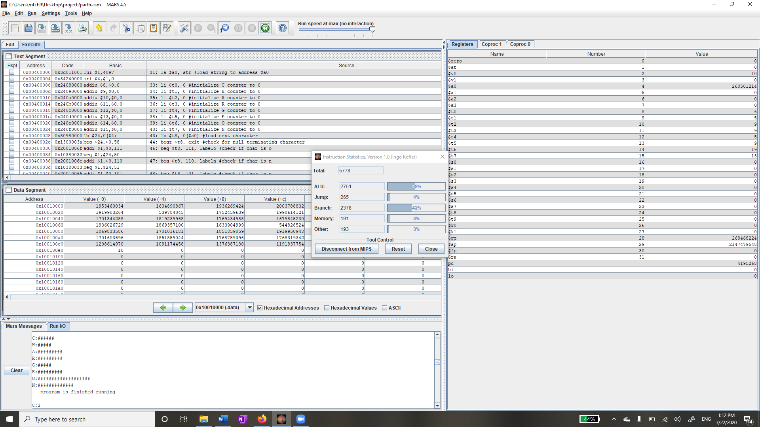

(193*4) + (5320*5) + (265*3) = 28167 clocks

(2751 * 4) + (265 * 5) + (2378 * 8) + (191 * 100) + (193 * 3) = 51032fj

Compared to unenhanced = 57344/51032 = 1.12 = 12% improvement

28167clk * 400psec = 11,266,800psec

5778x10-6 instructions

When we divide, we get = 512.83 MIPS

Power = Energy/time = 51032fj/11,266,800psec = 4.53 x 10-6 = 4.53 x 10-3mW

MIPS/mW = 512.83/4.53 x 10-3 = 113,207 MIPS/mW

1. “To assist N.C. Division of Motor Vehicle customers and partners in dealing with the impact of the coronavirus pandemic, a provision included in the COVID-19 bill signed into law today by Governor Cooper grants a five-month extension of the expiration date on more than two dozen DMV credentials.”

Character count: 296

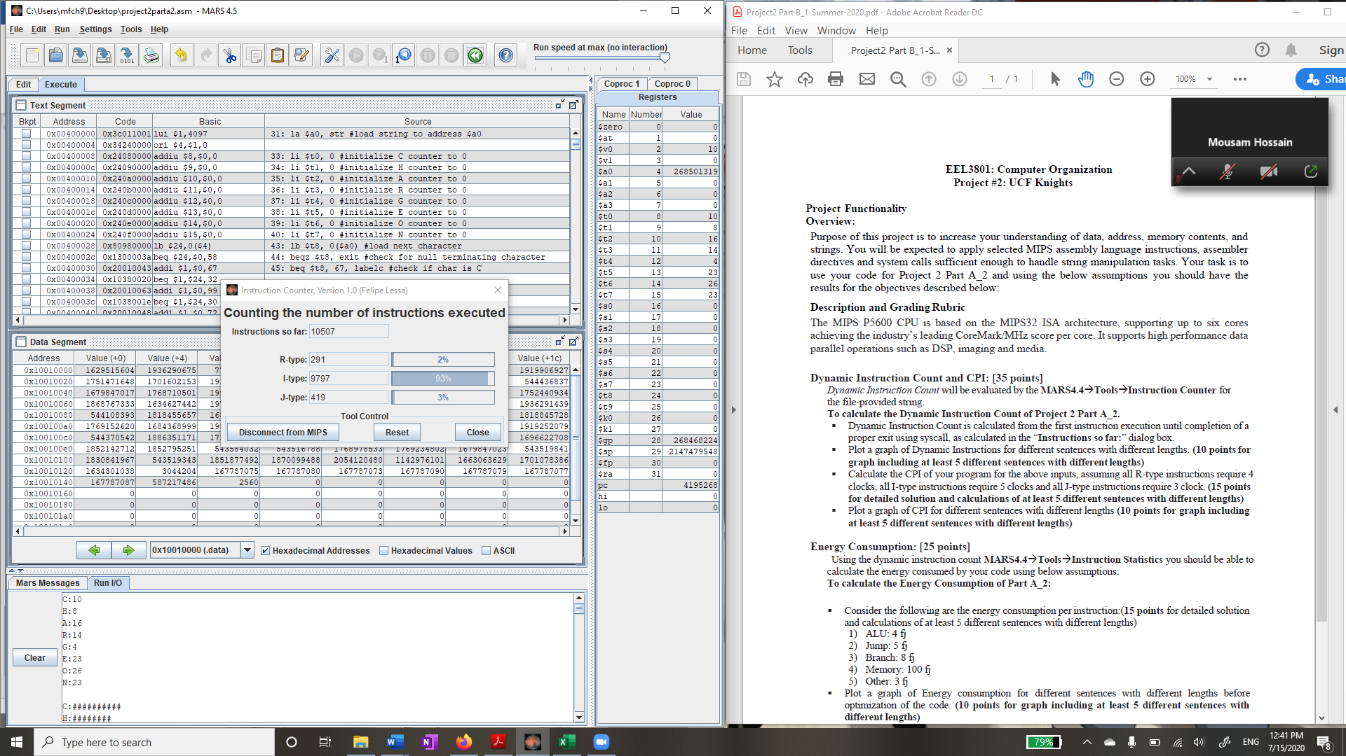

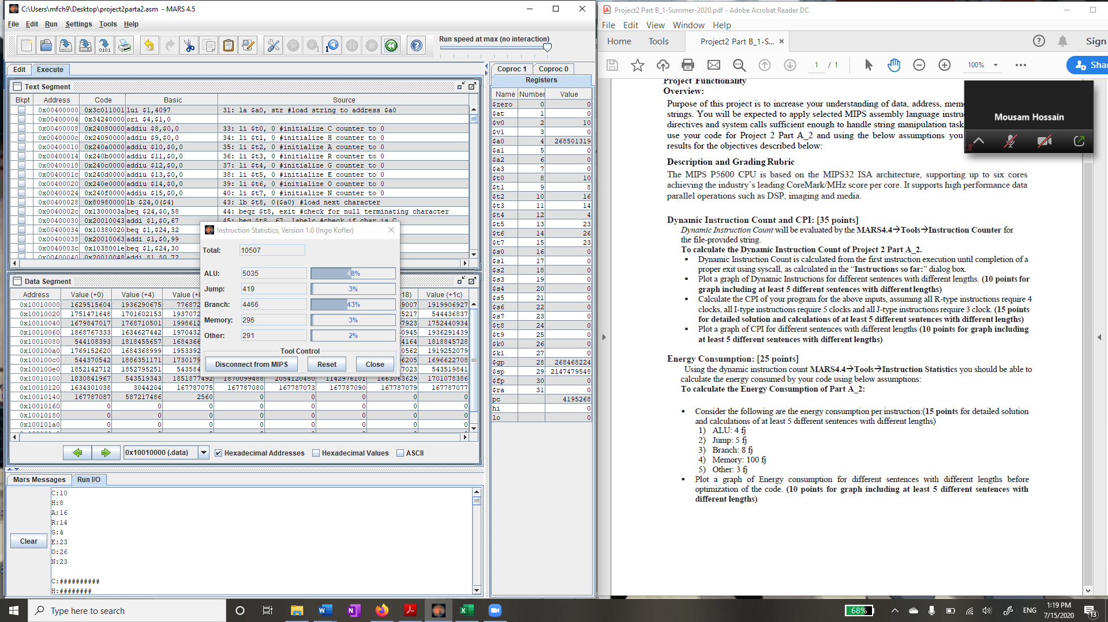

$\frac{\left(4×291\right)+\left(5×9797\right)+\left(3×419\right)}{10507}$ = 4.89 = CPI

$\left(5035×4\right)+\left(419×5\right)+\left(4466×8\right)+\left(296×100\right)+\left(291×3\right)$ = 93471fj

**After enhancing the code**

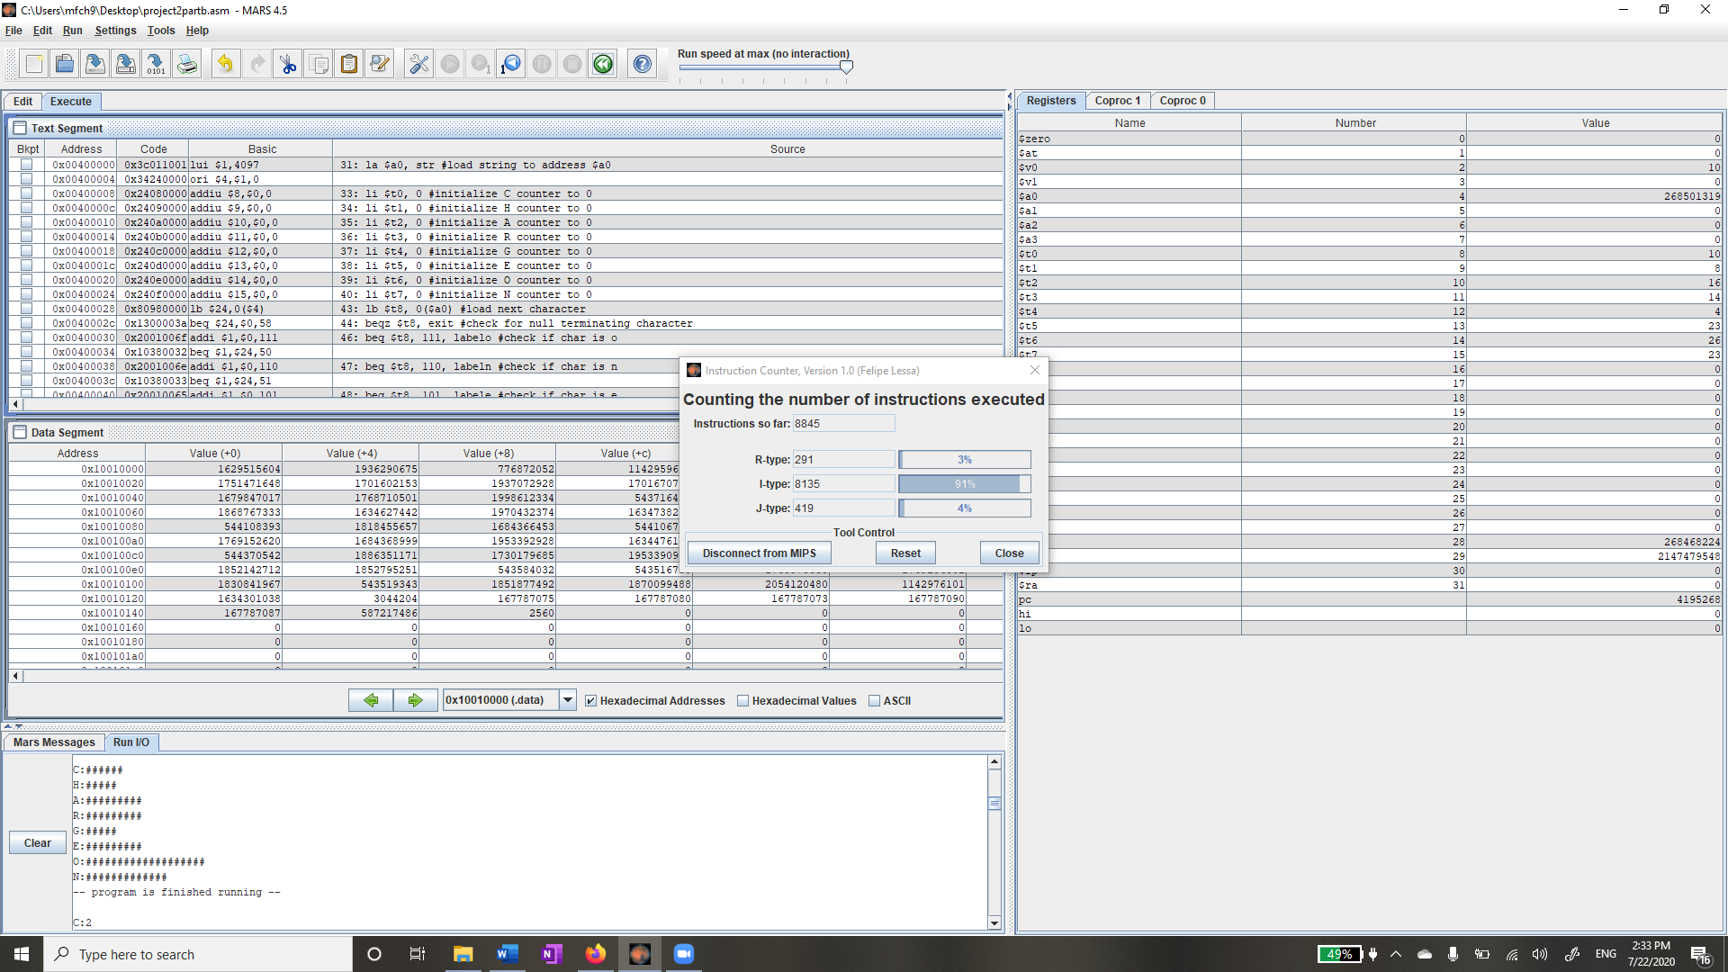

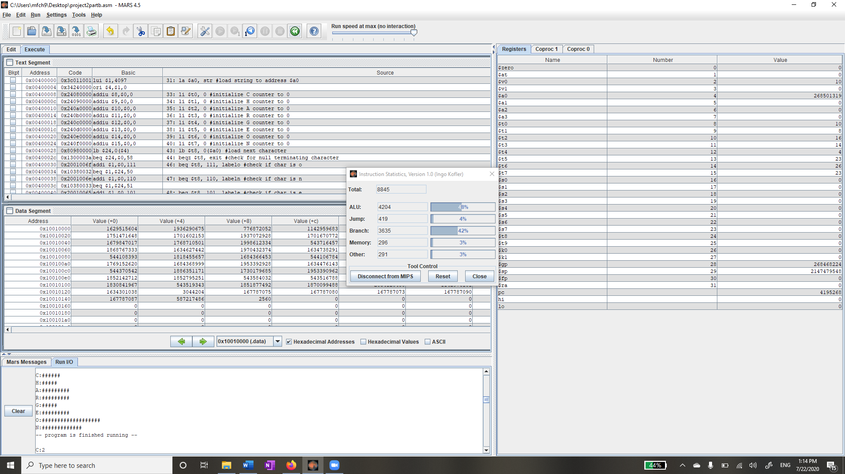

(291*4) + (8135*5) + (419*3) = 43096 clocks

(4204 * 4) + (419 * 5) + (3635 * 8) + (296 * 100) + (291 * 3) = 78464fj

Compared to unenhanced = 93471/78464 = 1.19 = 19% improvement

43096clk * 400psec = 17,238,400psec

8845 x 10-6 instructions

When we divide, we get = 513.12 MIPS

Power = Energy/time = 78464fj/17,238,400psec = 4.55 x 10-6 = 4.55 x 10-3mW

MIPS/mW = 513.12/4.55 x 10-3 = 112,773 MIPS/mW

From all the data we have compiled above we can create the following data graphs:

For unenhanced data:

Enhanced data graph:

1. **Learning Coverage**

Multiple skills were acquired while carrying out this project including:

* The use of additional MIPS tools to analyze data from the execution of a program.
* String storage and iteration through the string one character at a time.
* Ways to enhance the energy consumption of a program without altering its functionality.
* How to use program instruction statistics to calculate the energy consumption of a program.
* How to use an instruction counter to calculate the time to execute a given program.
* The use of labels to count specific characters in a string.

1. **Prototype in C-Language**

#include <stdio.h>

#include <stdlib.h>

#include <string.h>

int main(){

char input[] = "To assist N.C. Division of Motor Vehicle customers and partners in dealing with the impact of the coronavirus pandemic, a provision included in the COVID-19 bill signed into law today by Governor Cooper grants a five-month extension of the expiration date on more than two dozen DMV credentials.";

int i, c= 0, h = 0, a = 0, r = 0, g = 0, e = 0, o = 0, n = 0;

for (i = 0; i < strlen(input); i++) {

if (input[i] == 'C' || input[i] == 'c')

c++;

else if (input[i] == 'H' || input[i] == 'h')

h++;

else if (input[i] == 'A' || input[i] == 'a')

a++;

else if (input[i] == 'R' || input[i] == 'r')

r++;

else if (input[i] == 'G' || input[i] == 'g')

g++;

else if (input[i] == 'E' || input[i] == 'e')

e++;

else if (input[i] == 'O' || input[i] == 'o')

o++;

else if (input[i] == 'N' || input[i] == 'n')

n++;

else

continue;

}

printf("C: %d\nH: %d\nA: %d\nR: %d\nG: %d\nE: %d\nO: %d\nN: %d\n\n", c, h, a, r, g, e, o, n);

printf("C: ");

for (i = 0; i < c; i++)

printf("#");

printf("\nH: ");

for (i = 0; i < h; i++)

printf("#");

printf("\nA: ");

for (i = 0; i < a; i++)

printf("#");

printf("\nR: ");

for (i = 0; i < r; i++)

printf("#");

printf("\nG: ");

for (i = 0; i < g; i++)

printf("#");

printf("\nE: ");

for (i = 0; i < e; i++)

printf("#");

printf("\nO: ");

for (i = 0; i < o; i++)

printf("#");

printf("\nN: ");

for (i = 0; i < n; i++)

printf("#");

return 0;

}

1. **Test Plan**

For testing we can use the string provided in the example and check the output to make sure it matches. We can also test extreme cases where the string is empty, or it doesn’t include any of the characters we are looking for. We can also continue testing by using the 5 different strings we used throughout the project. For this test case label, I will only be showing one standard test case and the two extreme cases.

|  |  |  |
| --- | --- | --- |
| Test Case | String Input | Expected Output |
| Standard | “The Knights field 16 varsity teams (6 men's, 9 women's and one co-ed sport) that have won numerous national and conference titles. The UCF Knights Football team won conference championships in 2007 and 2010, and the Knights women's basketball team won conference titles the 2009 and 2010.” | C: 9  H: 11  A: 17  R: 6  G: 3  E: 27  O: 16  N: 26  C:#########  H:###########  A:#################  R:######  G:###  E:###########################  O:################  N:########################## |
| Empty String | “” | C: 0  H: 0  A: 0  R: 0  G: 0  E: 0  O: 0  N: 0  C:  H:  A:  R:  G:  E:  O:  N: |
| String with no appropriate letters | “qwtffy uiosdxz yyuypok tuqwrxnv bvnmdy” | C: 0  H: 0  A: 0  R: 0  G: 0  E: 0  O: 0  N: 0  C:  H:  A:  R:  G:  E:  O:  N: |

1. **Test Results**

Standard test:

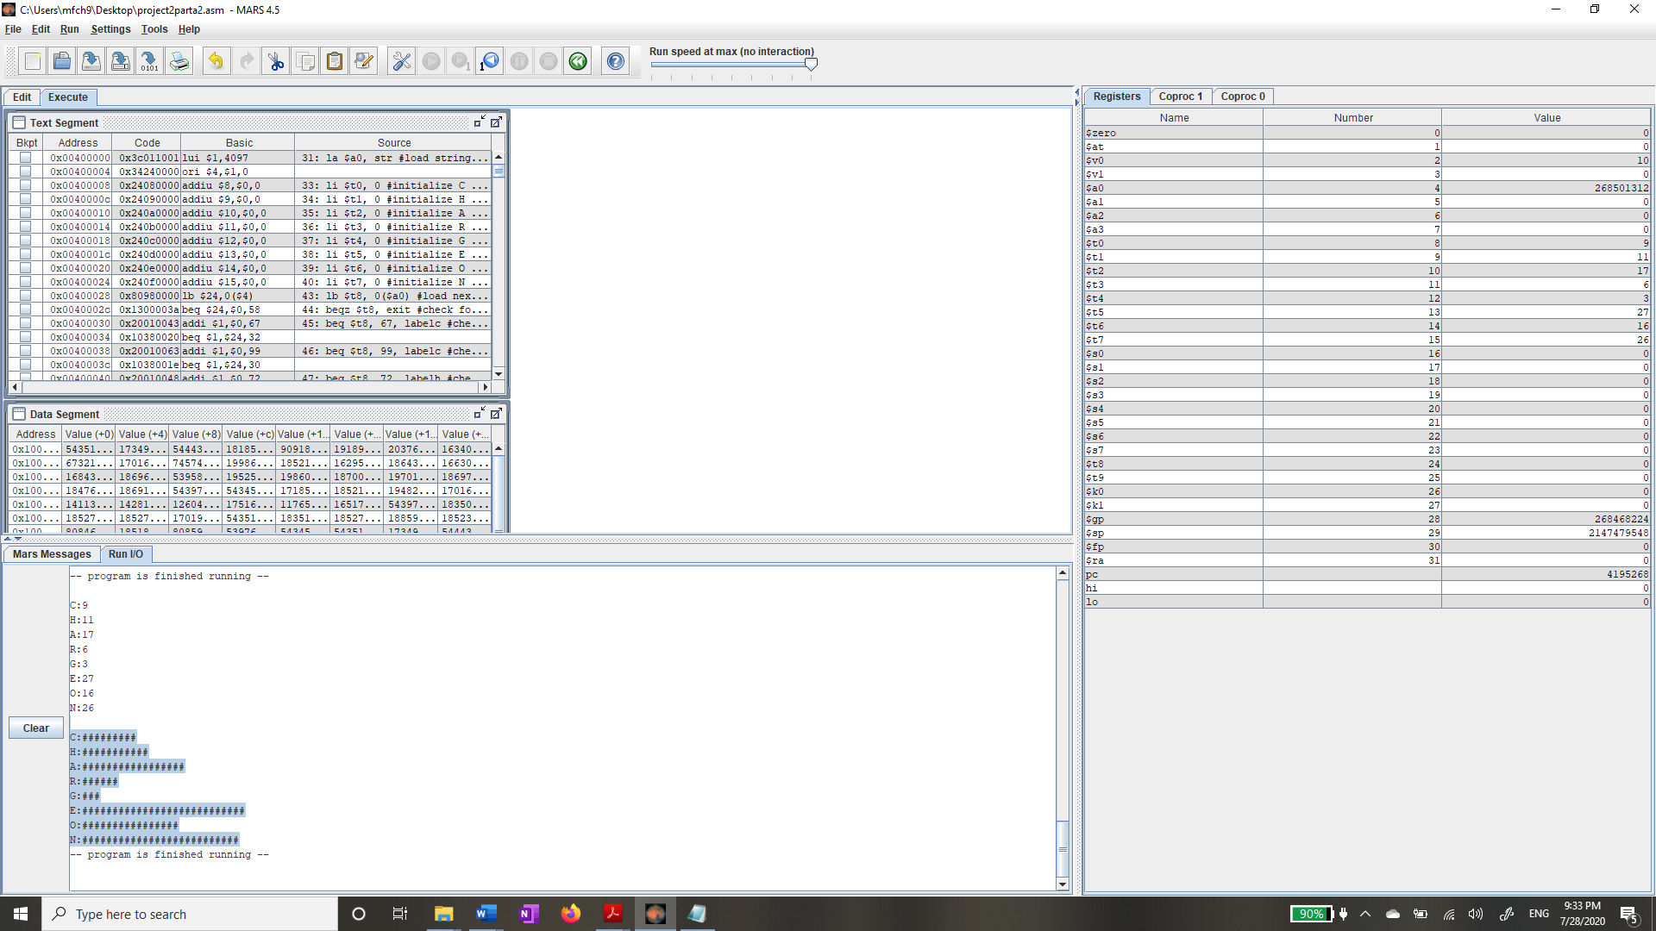

Empty string:

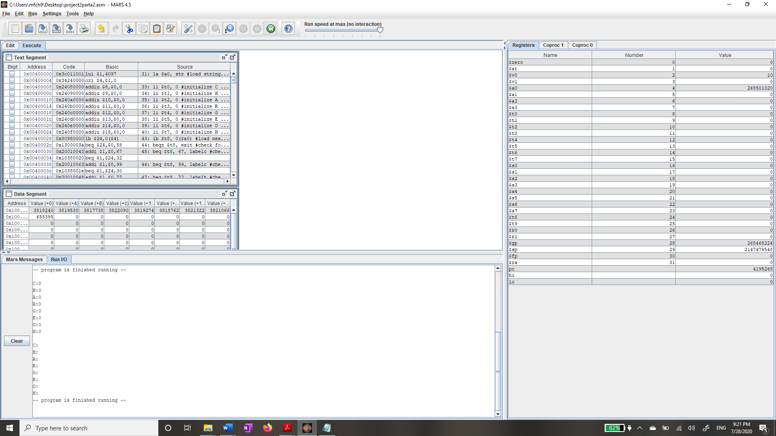

String with no appropriate characters:

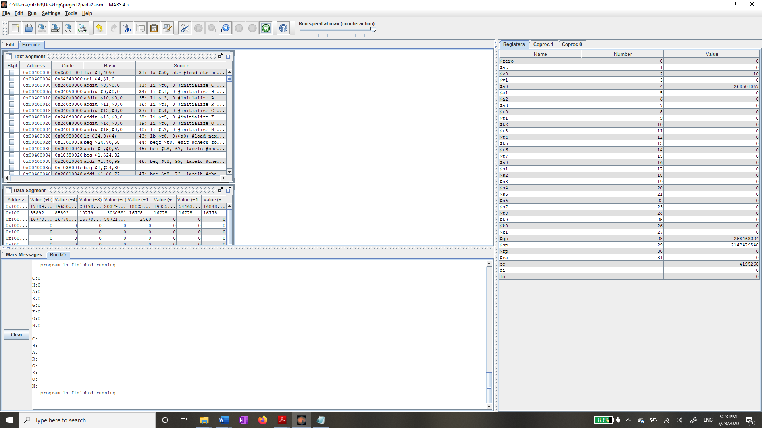

1. **References**
   1. **Lecture Slides**

EEL3801 DeMara Module 03-MIPS-ISA. Available on Webcourses.

* 1. **Project Instructions**

EEL3801 DeMara Project2 Part A_1_Summer20. Available on Webcourses.

EEL3801 DeMara Project2 Part A_2_Summer2020. Available on Webcourses.

EEL3801 DeMara Project2 Part B_1-Summer-2020. Available on Webcourses.

EEL3801 DeMara Project2 Part B_2_Summer 2020. Available on Webcourses.

EEL3801 DeMara Positive-Example-of-Project-Report. Available on Webcourses.

EEL3801 DeMara Project2-report grading rubric. Available on Webcourses.

* 1. **MARS Simulator**

MARS Simulator for MIPS processors. http://courses.missouristate.edu/kenvollmar/mars/download.htm

* 1. **Testing Reference Sheet**

EEL3801 DeMara EEL3801-Testing-Reference-Sheet. Available on Webcourses.